 CHEMICAL ENGINEERING TRANSACTIONS  VOL. xxx, 2026 | A publication of  
The Italian Association
of Chemical Engineering
Online at www.cetjournal.it

Guest Editors: Laura Capelli, Marzio Invernizzi, Selena Sironi
Copyright © 2026, AIDIC Servizi S.r.l.
ISBN 979-12-81206-xx-x; ISSN 2283-9216

TO vs RTO for the treatment of VOCs in industrial emissions. Techno-economic analysis applied to multicomponent gas streams in the chemical and pharmaceutical sectors
Stefano Zannier, Nicolò Zocche*
Fives ITAS SpA, Via Metauro 5, 20900 Monza (MB), ITALY
nicolo.zocche@fivesgroup.com
This paper presents a techno-economic comparison between two plant configurations, respectively based on recuperative thermal oxidizers (TO) and regenerative thermal oxidizers (RTO), analysing their operating principles, energy performance and key design parameters, with particular focus on heat recovery aspects, utilities and reagents consumption, operational flexibility and integration with auxiliary treatment such as neutralization units for halogenated compounds (e.g. quenchers/scrubbers packages).
The work also includes the analysis of a real application case in the chemical-pharmaceutical sector, concerning the treatment of gas streams containing VOCs with both hydrocarbon and halogenated matrix, in which both technological solutions were evaluated through thermo-fluid dynamic simulations and cost models based on realistic operating conditions. The comparison allows to quantify the differences, particularly in terms of specific fuel consumption, annual operating costs, payback time, and impact on the plant life cycle.
The results show that the selection of the optimal configuration cannot be separated from an integrated analysis of the physic-chemical characteristics of the gas streams, the specific operating conditions, and the relevant process parameters. In this context, the availability of both technologies and the ability to assess their applicability through a systemic engineering approach represent a key factor for optimizing the environmental and energy performance of industrial plants.
  - Introduction
The treatment of gaseous emissions containing Volatile Organic Compounds (VOCs) represents one of the main engineering challenges in the chemical and pharmaceutical industries, which are characterized by high variability of gas streams, presence of multicomponent mixtures and stringent requirements in terms of abatement efficiency, safety, and operational continuity.
In this context, recuperative thermal oxidizers (TOs) and regenerative thermal oxidizers (RTOs) represent the reference technologies for controlled thermal oxidation of VOCs, ensuring abatement efficiencies above 99%.
The purpose of this analysis and comparison is to verify that TOs are preferable in scenarios characterized by lower flow rates, high and variable concentrations, presence of highly corrosive compounds, extreme operating temperatures, or the need for more complex plant configurations, offering greater operational flexibility with reasonable investment costs (CAPEX). Conversely RTOs, thanks to their high thermal recovery efficiencies (up to 95–97%), can be particularly advantageous in the presence of large flow rates, low and stable VOC concentrations, enabling significant reductions in energy consumption and operating costs (OPEX).
    - General context and operating frame
The treatment of gaseous streams containing both hydrocarbon and halogenated Volatile Organic Compounds (VOCs) requires thermal oxidation systems capable of ensuring high destruction and removal efficiency (DRE > 99%) and the subsequent neutralization of the generated acids (e.g. HCl, HF).
In fact, both systems convert chlorine (if any) into gaseous inorganic acids (e.g., HCl), which can cause severe corrosion, therefore both require special materials and a downstream scrubber.

    - Input data and basic assumptions
Below is presented a comparison between TO and RTO under the same following input conditions:
Gas volumetric flow rate: 10,000 Nm³/h
Inlet temperature: 50°C
VOC concentration (total load of hydrocarbons + halogens): 0÷10 g/Nm³
Hydrocarbons (e.g. alkanes, as ethane): 70÷80%
Estimated average LHV: 46 MJ/kg
Halogenated (e.g. chlorinated, as DCM): 20÷30%
Estimated average LHV: 6 MJ/kg
Oxidation temperature: 950°C with a residence time of 1 s
Destruction and Removal Efficiency (DRE): > 99,8%
Annual operating hours: 8,000 h/year
Additional flue gas treatment: legally required downstream scrubber against acid gases.
  - Reference technologies
For TO the cylindrical combustion chamber (horizontal type) is equipped with a gas combustion system including centrifugal fan to supply combustion air to process burner. A heat exchanger, positioned at the exit of the combustion chamber, allows thermal recovery by off-gas preheating and corresponding reduction of flue gas temperatures. Downstream of the main system, to reduce the temperature of the treated stream and abate the HCl in order to comply with the emission limits, a quencher/scrubber package will be installed. Then a process centrifugal fan ensures the movement of the flue gas until the stack for the expulsion into the atmosphere. For RTO, the combustion chamber is sized to ensure sufficient destruction efficiency in the worst operating conditions. The internal temperature is maintained thanks to a temperature control loop that regulates the possible addition of support gas and combustion air inside the chamber. The combustion temperature and residence time guarantee, with a margin, the destruction of the VOCs inside the flow to be treated, in accordance with the Best Available Technologies. The quenching tower with water spray system, placed downstream of the RTO, allows to cool the gas before the wet basic scrubber, that is appointed to guarantee the total abatement of acid gases and residual chlorinated VOCs. The scrubber is connected to the ID fan and exhaust gas stack.
    - Process flow diagrams with heat and mass balances
Both thermal oxidizers can achieve very high DRE (>99%) by maintaining the pollutant stream at a targeted temperature above its autoignition temperature for a specific amount of time (residence time) in the presence of adequate levels of oxygen. For the related heat and mass balances refer to Fig.1 and Fig.2.
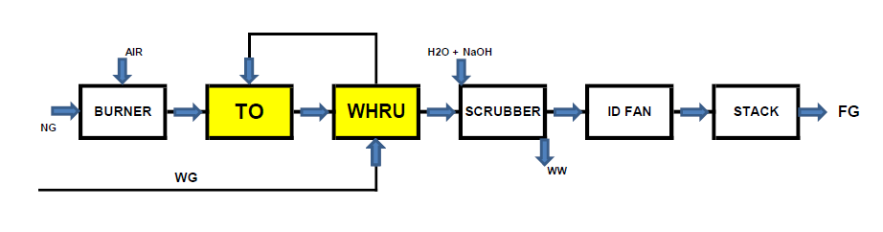
Figure 1: PFD for Recuperative Thermal Oxidizer (TO+WHRU) with Quencher/Scrubber Package
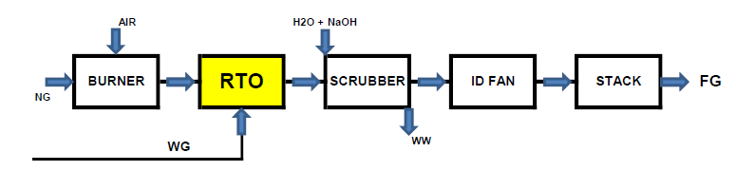
Figure 2: PFD for Regenerative Thermal Oxidizer (RTO) with Quencher/Scrubber Package

The incoming process gas, based on its flow rate, composition, temperature and Low Heating Value (LHV), defines the heat energy going into the oxidizer. Other incoming sources include auxiliary fuel and combustion air. Heat energy is lost from the system through the stack and radiant losses from ductwork and system walls. The supplemental thermal energy required to heat process gases is the difference between the outlet heat less the inlet heat and the contribution from combustion of the process gas. When the energy from the VOCs equals the energy required to maintain adequate chamber temperatures, the system is deemed autothermal, and supplemental energy is unnecessary. As the energy increases above the requirements, the system efficiency needs to be reduced to stay in balance. Processes with low energy contribution from the combustion process are ideally treated with a recuperative thermal oxidizer with very high heat exchanger efficiencies or a regenerative thermal oxidizer.
Table 1: Simplified heat balance for TO and RTO with the gas flow rate of par. 1.2 (without VOCs)
Parameter | TO (Recuperative Thermal Oxidizer) | RTO (Regenerative Thermal Oxidizer)
Process gas heating up to the combustion temp | 3.600 kW | 3.600 kW
Heat recovery | 2.500 kW | 3.400 kW
Heat from burner (NG) | 1.100 kW | 200 kW
NG consumption | 110 Nm3/h | 20 Nm3/h

    - Technical constraints
The presence of halogens: the combustion of chlorinated VOCs generates gaseous hydrochloric acid (HCl). With a recuperative TO, the exchanger is entirely metallic. Although the gas temperature must not fall below the acid dew point to avoid acid corrosion (often prevented with adequate insulation), the internal refractory material and the direct exchange method are stable. In RTOs, however, the acid passes through ceramic beds; if the dew point is reached during the thermal cycle or during equipment downtime, salts can form and deep corrosion can occur, resulting in an early drop in bed efficiency.
Hence, for recuperative TO the primary exchanger must be constructed of special corrosion-resistant alloys (e.g., Hastelloy, SMO 254, etc.), for RTO some critical parts as inlet ducts/hoopers/ceramic supports and outlet ducts, must be made of special materials (e.g., SAF 2205, SAF 2507, etc.).
Besides, for RTO the ceramic beds can be subject to chemical attack or acid dew corrosion if the temperature drops locally; however, the steel of the machine body is less exposed than the direct exchanger.
The risk of clogging: TO does not feature ceramic beds or reversing valves, making it significantly more reliable and robust for dirty or high-risk gas flows, for RTO the halogenated compounds or co-pollutants in the flow can generate dust or polymers that settle in the ceramic material, clogging it. This can increase pressure drops and require shutdowns for maintenance. Ultimately, in the event of chemical attack by high-temperature chlorine compounds, replacing the ceramic bed in the RTO can increase maintenance costs.
  - Case study
    - Technology comparison: process and design
The topic of this paper is to specifically review the performance of Recuperative Thermal Oxidization versus Regenerative Thermal Oxidization systems and assess which applications favor each technology.
In general, processes with medium energy contribution from the combustion process are ideally treated with a recuperative TO combined with high heat exchanger efficiencies or RTO equipped with hot bypass system.
In addition to the initial capital cost of the air pollution control equipment, key considerations also include ongoing operating costs including utilities, maintenance expense, equipment life and reliability.
The utilities consumptions are related to the balances described at par. 2.1, while the other parameters (in particular reliability) depend on numerous factors, such as those indicated here below.
Presence of critical compounds (e.g. particulates) in the incoming flow can foul the equipment and negatively impact the performance. When these upsets occur, equipment down-time and repair may be necessary.
For a recuperative thermal oxidizer, this generally means that the heat exchanger and combustion chamber may need to be opened to allow the tubes and chamber cleaning.
For a regenerative thermal oxidizer severe case can require removal of the ceramic media and replacement with new media.
Additionally, both oxidizers have fans that operate continuously but RTO has diverter valves, which shift frequently to change the direction of flow through the system, therefore subject to significant wear and tear.
In our case a chemical industry explored an efficient and effective way to treat their VOC laden waste gas. Multiple reactors produced the waste gas, collected into an equalization tank prior to VOC abatement. The overall exhaust stream to be treated is relatively small and contains alkanes, alcohols and other organic compounds of significant heating value as well as some halogenated compound of lower calorific value.
The analysis led to conclude that both oxidizers are suitable for meeting the process needs, with some important differences: the recuperative thermal oxidizer easily meets the performance objectives without the need for much dilution air, the regenerative thermal oxidizer design can require additional air to control the temperatures and also a hot gas bypass to provide options towards the VOCs concentrations and fluctuations.
In any case both systems are sized to handle low, average and maximum peak loadings efficiently through the use of a Variable Frequency Drive (VFD) controlling dilution air.
But the RTO does not offer the flexibility to handle the potential process upsets.
In fact, although the system claims a high thermal efficiency, sometimes (under operating conditions with too many or too energetic VOCs) in the RTO the energy is used to heat a large amount of unneeded dilution air.
Table 2: Main differences between TO and RTO
Characteristic | TO (Recuperative Thermal Oxidizer) | RTO (Regenerative Thermal Oxidizer)
Recovery method | Heat exchanger in metal alloy | Structured ceramic beds (regenerative)
Thermal efficiency (TER) | 50÷70% | 94÷98%
Gas preheating temp. | 400÷600°C | Close to combustion temp
Thermal self-sufficiency | Requires continuous fuel support (NG) | Auto-thermal with VOC > 2 g/Nm³
Halogens management | Excellent. Metal exchangers are less susceptible to acid salt buildup and thermal shock corrosion. | Complex. Thermal and inversion cycles can promote corrosion of ceramic beds (requires high-strength ceramic).

    - CAPEX analysis
Generally, the initial capital cost for a Recuperative Thermal Oxidizer is similar to a Regenerative Thermal Oxidizer for the same size system. Many of the components are the same in both systems with exception that the recuperative oxidizer has a shell and tube heat exchanger, whereas the RTO has three or more chambers of media and a valve or drive system to alternate flow. Otherwise, they both have a combustion chamber, burner/gas train, combustion air and process blowers, system controls and safety interlocks, additional flue gas treatment systems, exhaust stack and interconnecting ductwork.
The values are purely indicative and based on current market trends for complete turnkey systems, including plant engineering and project management as well as supply of mechanical auxiliary equipment (BoP) and electro-instrumental systems.

Table 3: Investment costs of the main systems for TO vs RTO technology
CAPEX Voice | TO Rec. (€) | 3-Towers RTO (€) | Notes
Oxidation unit | 750.000÷900.000 | 950.000÷1.150.000 | Standard chamber vs. towers, hoppers, valves & ceramic beds
Heat recovery unit | 200.000÷250.000 | Included | Metal exchangers vs ceramics with high efficiency for RTO
Acid gas abatement | 300.000÷400.000 | 300.000÷400.000 | Mandatory for halogens
Electric & control systems | 150.000÷200.000 | 150.000÷200.000 | Similar equipment
BoP + Eng. & project mgt | 100.000÷150.000 | 100.000÷150.000 | Equivalent items and services
Overall plant | 1.500.000÷1.900.000 | 1.500.000÷1.900.000 | Turnkey solutions lead to very similar CAPEX

    - OPEX analysis
The main operating cost associated with thermal oxidation is the energy necessary to operate the system.
In fact, the VOCs destruction is achieved by raising the incoming stream to the required temperature.
A Recuperative Thermal Oxidizer accomplishes this energy recovery by using a heat exchanger, typically shell and tube design, to transfer some of the heat leaving the combustion chamber to preheat the process gas entering the thermal oxidizer. This primary heat exchanger is generally economical at between 50÷70% thermal efficiency. A Regenerative Thermal Oxidizer uses ceramic media to capture and store thermal energy from the system and then re-uses the energy to preheat the process gases entering the oxidizer. Nominal thermal efficiency is generally around 95%. Overall energy usage depends on the energy contribution from the VOCs, other incoming fuels, and the efficiency of the energy recovered either in the heat exchanger or the ceramic media.
Estimates here below are calculated on 8,000 h/year and based on the following utilities and reagent costs: Natural gas 0.50 €/Nm³, electric energy 0.15 €/kWh, soda for scrubber (NaOH 20% sol.) 0.20 €/kg.
Table 4: Operation & maintenance costs for TO vs RTO technology
Voice of OPEX | TO Rec. (€/y) | 3-Towers RTO (€/y) | Justification / Calculations
NG Consumption | 100.000÷200.000 | 20.000÷40.000 | TO has a lower heat recovery, more NG is needed to maintain combustion temp
Electricity Consumption | 25.000÷30.000 | 35.000÷50.000 | RTO requires more powerful and constant fans to overcome the pressure drops of ceramic beds
Reagents (NaOH sol.) | 45.000÷70.000 | 45.000÷70.000 | Equal, for the same products (HCl).
Maintenance & Spares | 40.000÷60.000 | 60.000÷90.000 | RTO has pneumatic valves that are subject to wear and requires periodic recharging of the ceramics.
Overall plant | 210.000÷360.000 | 160.000÷250.000 | RTO guarantees net annual savings
  - Conclusions
The results show that the selection of the optimal technology cannot be separated from an integrated analysis of the physic-chemical characteristics of the gas streams, the specific operating conditions, and the relevant process parameters. In this context, the availability of both technologies and the ability to assess their applicability through a systemic engineering approach represent a key factor for optimizing the environmental and energy performance of industrial plants.
In fact, recuperative TO perform well in treating streams with medium-high energy loads, RTOs are suited for larger flows with low energy contribution. The composition of the gas stream, destruction efficiency requirements and plant availability are also essential parameters to evaluate before making a decision on the more suitable technology. Furtherly, the most appropriate application for Regenerative Thermal Oxidizers are processes where VOC loading is relatively low in proportion to a high flow rate, not containing significant particulates or condensable. As low VOC concentration in the stream does not contribute much energy towards raising the combustion chamber to the required temperatures, higher energy efficiency of the RTO is beneficial for reducing the need for auxiliary gas consumption. Alternatively, the RTO’s high energy efficiency is not as beneficial in streams that contribute significant amounts of their own energy. RTO can be applied in these situations by modifying the equipment and its typical operating modes, that include addition of significant amounts of dilution air to generate a cooling effect, permanent reduction of the thermal efficiency by installing fewer ceramic media, or provision of a hot gas by-pass system to temporarily decrease the RTO’s thermal efficiency.
The final result of the discussion can therefore be the following: for discontinuous cycles (e.g. plant operation less than 2.000÷3.000 h/y), irregular flows, or heavy halogenated loads that require expensive special alloys, the recuperative TO system is preferable due to its greater structural robustness and lower maintenance costs.
However, if the system operates continuously (e.g., 24/7 at least 5.000÷6.000 h/y) and the halogenated flows are kept under control to avoid corrosive shock, the RTO is the optimal choice from the economic and environmental point of view; in fact it can guarantee significant energy savings thanks to a thermal efficiency close to 95% and, despite higher electricity and maintenance costs, the RTO can repay the investment difference in a timeframe of 2.5-4 years compared to the TO.
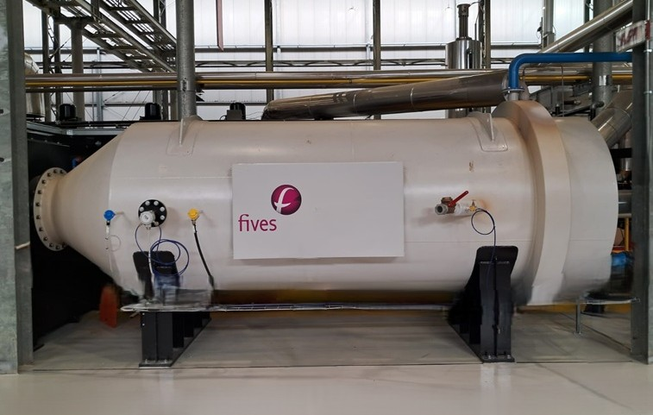
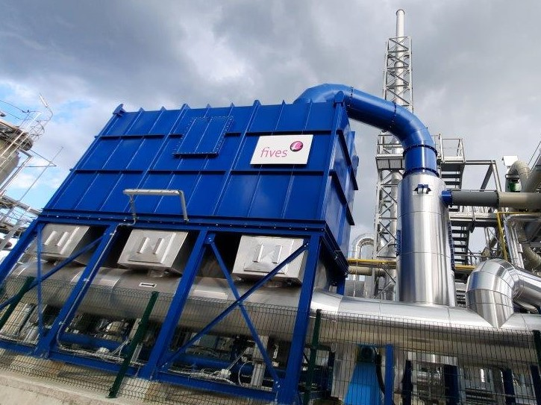
Figure 4: Regenerative Thermal Oxidizer (RTO) on the left and horizontal Thermal Oxidizer (TO) on the right.
References
Baukal C.E.Jr., 2014, The John Zink Hamworthy Combustion Handbook, Second Edition, Vol. 3, Applications, Taylor & Francis Group, Boca Raton, USA.
EPA, 2017, November, Chapter 2 - Incinerators and Oxidizers. Retrieved from United States Environmental Protection Agency, USA.
Guerra M.N., Marques C., 2018, Volatile Organic Compound Emission Reduction and Abatement within the Organic Fine Chemical Industry, Thesis to obtain the Master of Science Degree in Biological Engineering, Instituto Superior Tecnico, Lisboa, Portugal.
JRC, 2022, Best Available Techniques (BAT) Reference Document for Common Waste Gas Management and Treatment Systems in the Chemical Sector, Final Draft, 2022.
Lewandowski, 2017, D.A. Design of Thermal Oxidation Systems for Volatile Organic Compounds; CRC Press: Boca Raton, FL, USA, 157–168.
Pu G., Li X., Yuan F., Numerical Study on Heat Transfer Efficiency of Regenerative Thermal Oxidizers with Three Canisters, Processes 2021, 9, 1621
Trimpe J.Jr., 2021, Waste Heat Recovery of Industrial RTO, A Case Study, Theses and Dissertations-Mechanical Engineering, University of Kentucky, USA.
Zdanowski F., Malico I., Canhoto P., Lima R.P., 2023, Simulation of a Thermal Recuperative Incinerator of VOCs with a Special Focus on the Heat Exchanger, Math. Comput. Appl. 2024, 29, 1.

